SVN_GIT MIGRATION:

1.We need to have GIT-BASH installed in the machine

2.Create an empty folder

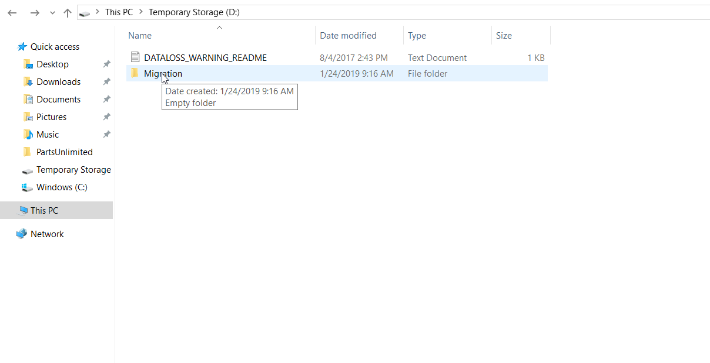

3.Open the folder and start Git-Bash from there or Open CMD-prompt in ADMINISTRTIVE Mode and navigate to the folder

4.Run the following command <git svn init "SVN Repository URL" --no-metadata>5.5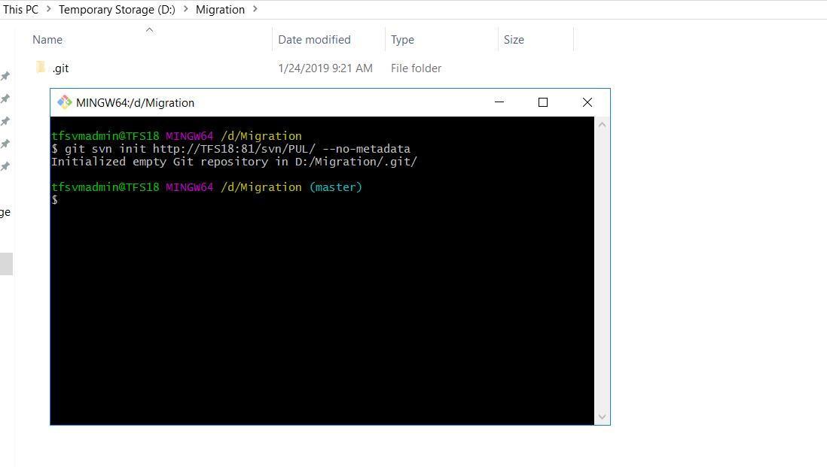

5.In the above pic you can see we have initialized a git repo

6. Run <git svn fetch> -->Fetching from SVN and saving it in Local folder

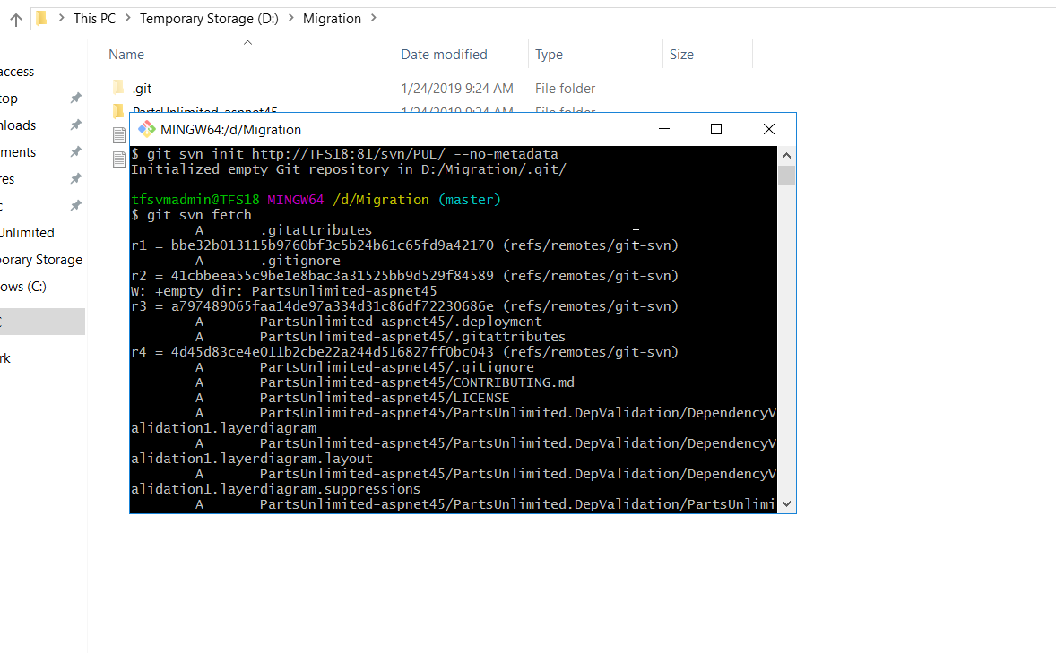

7.give the required credentials and enter

8.Create an empty project in TFS/AZURE-DEVOPS

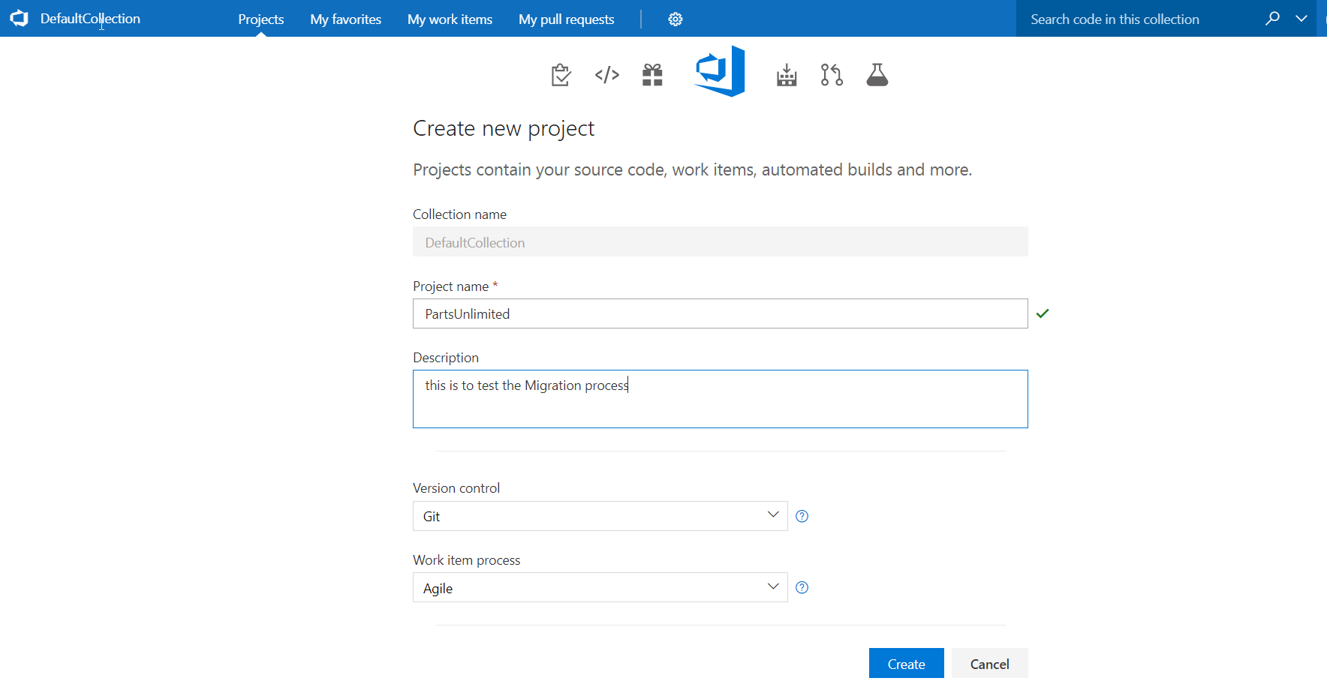

9.Copy the Git URL

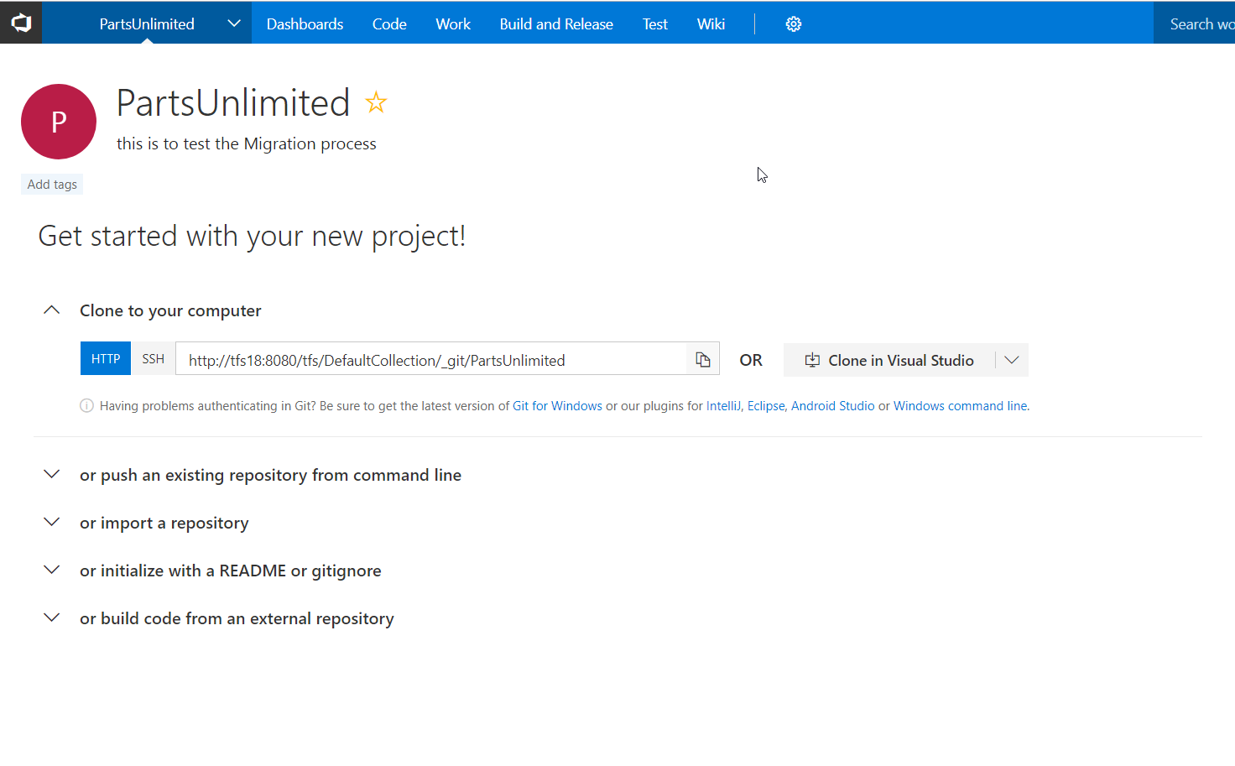

10.Run <git remote add origin "GIT Repository URL" > -->Adding TFS/VSTS GIT repository

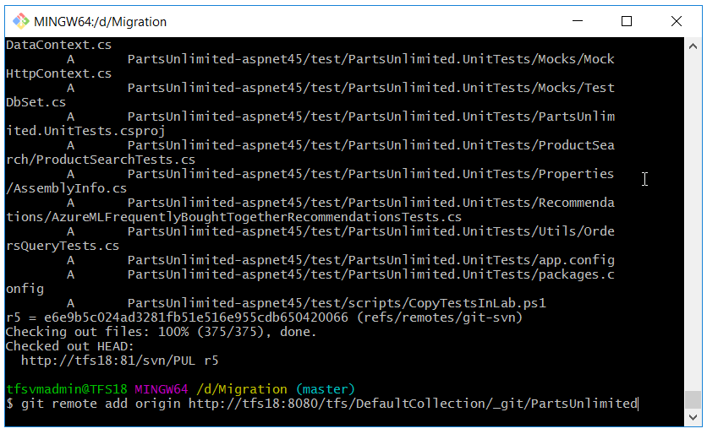

11.Run <git push -u origin --all>

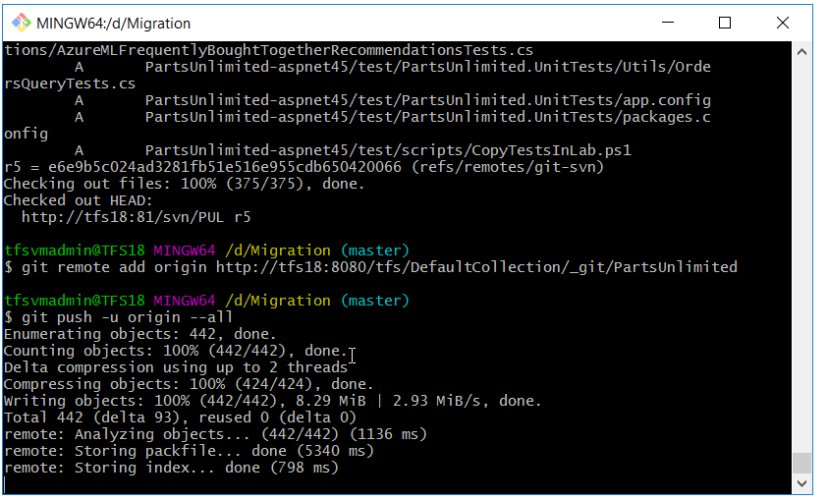

12.Refresh your TFS page and you can see the code

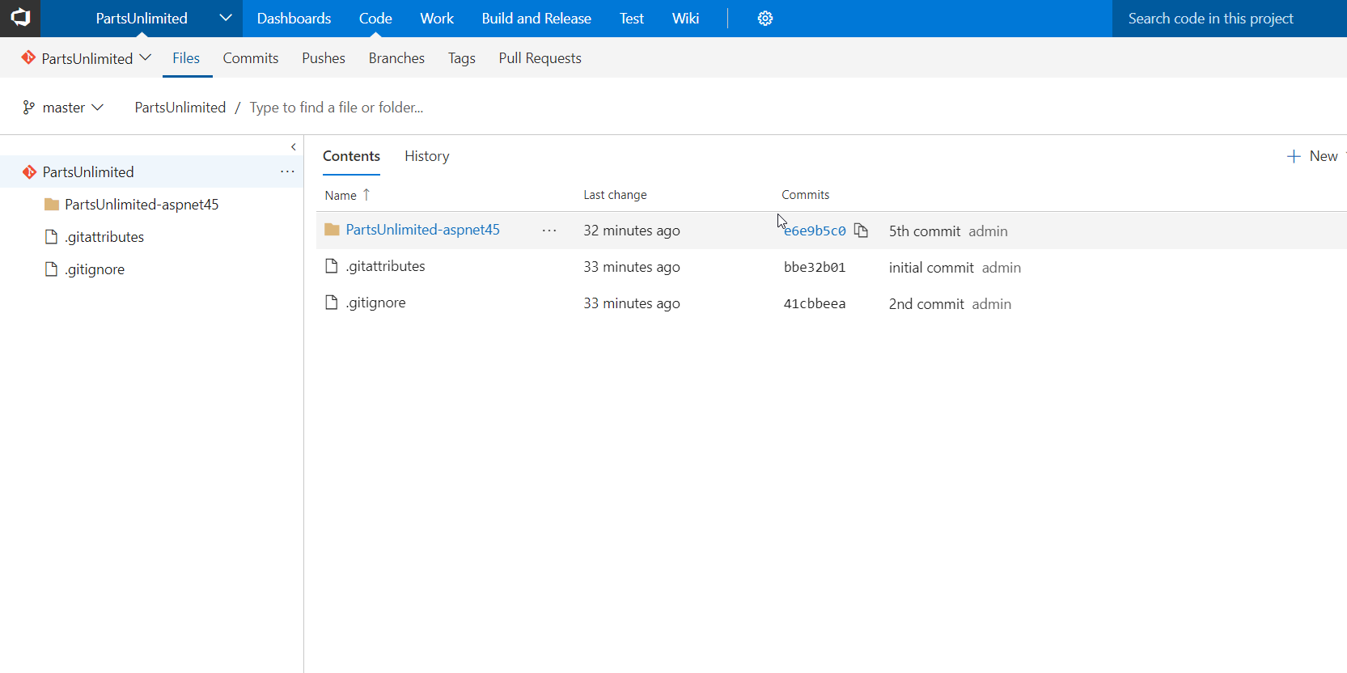

13.Check for the History

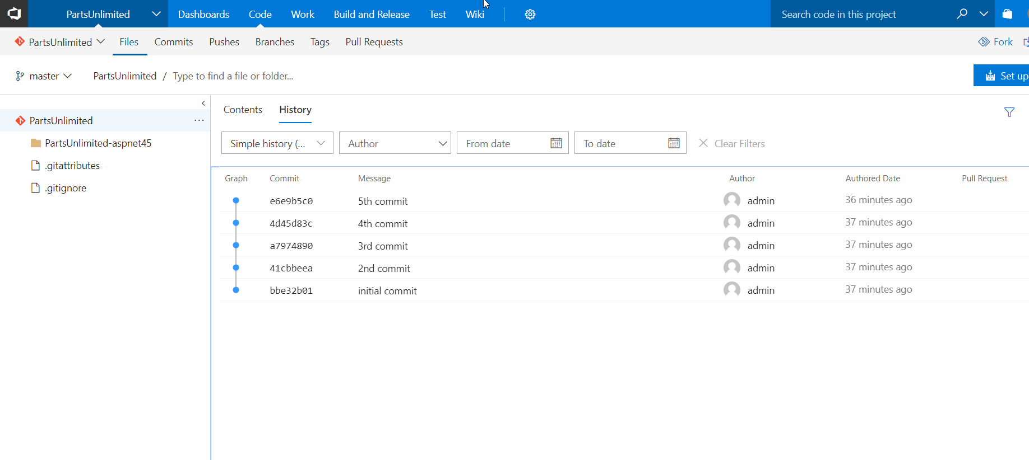

NOTE:- If you are facing any issues first things to check is the Port & Protocol of SVN